Lab Report: EECS 142 Lab#1 Calibration Network Analyzers & Tools and Tips for RF Electronics

Pre-Lab

1.S-parameters of the open in manual calibration

Magnitude(db):

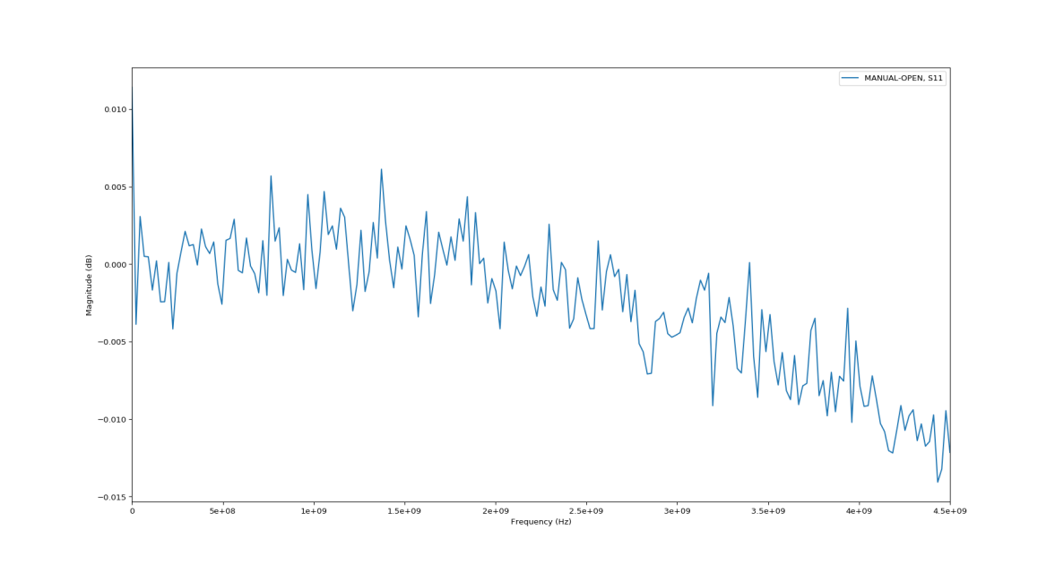

Phase:

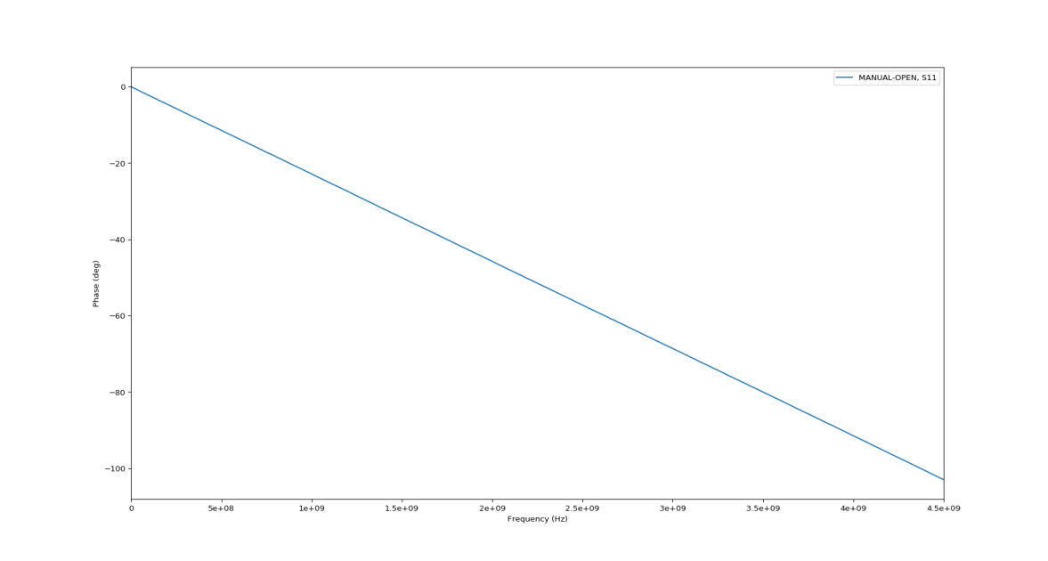

Smith Chart:

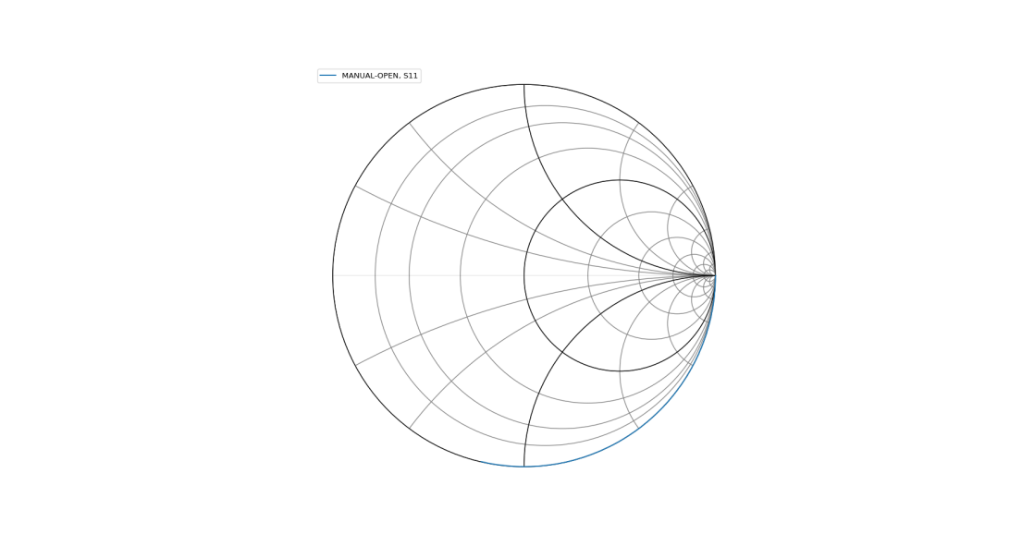

In the pre-lab, I predicted S-parameter of open should be 1, with the phase to be 0. However, in the experiment, phase is decreasing with frequency and the magnitude deviates from 0 dB. My explanation to this phenomenon is that there is a transmission line between the open standard and the cable, which caused distortion of magnitude and phase.

2.S-parameters of the open in electronic calibration

Magnitude:

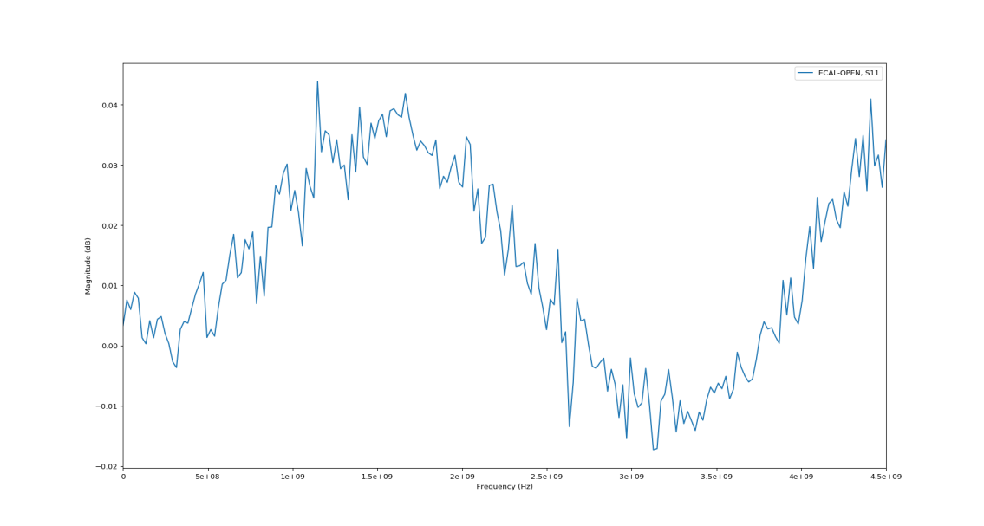

Phase:

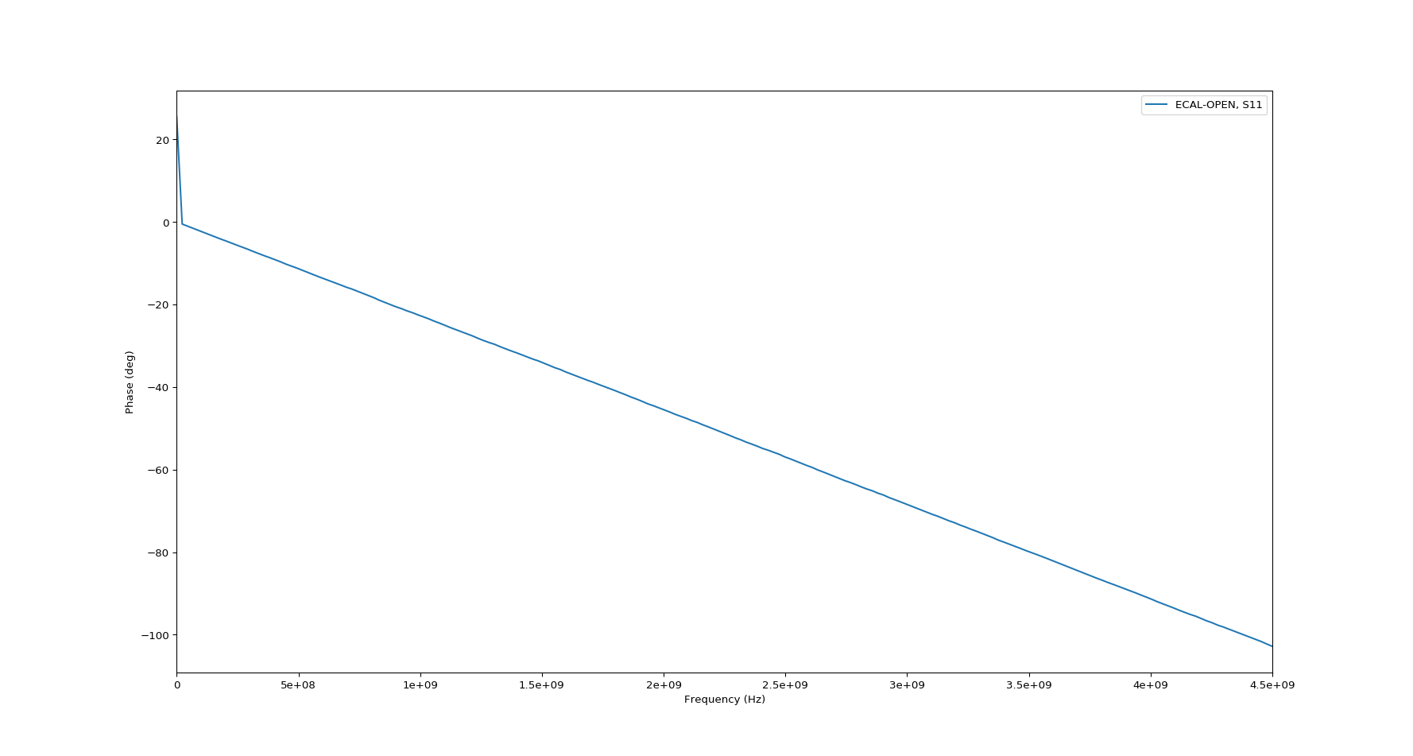

Smith Chart:

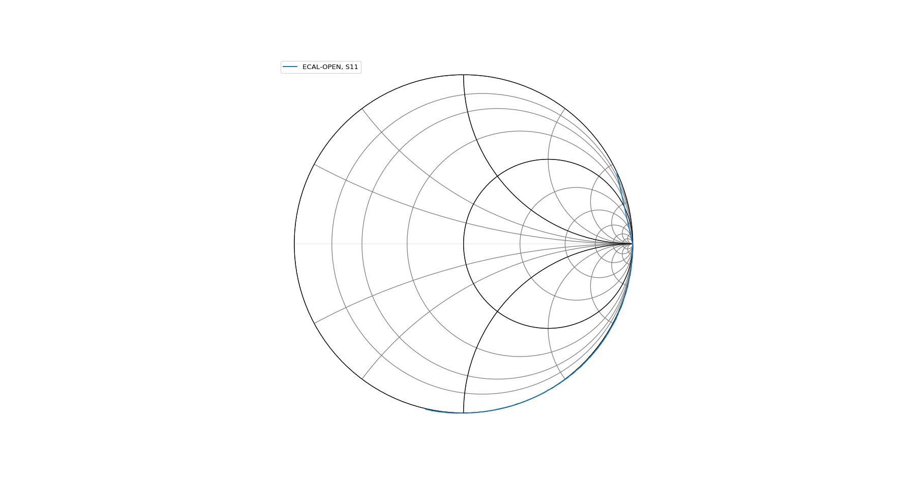

There is also a transmission line in between the open standard and the cable. There is a line in upper half plane in the smith chart, which is different from that of the result of manual calibration.

3.S-parameters of the female–female through adapter

Magnitude:

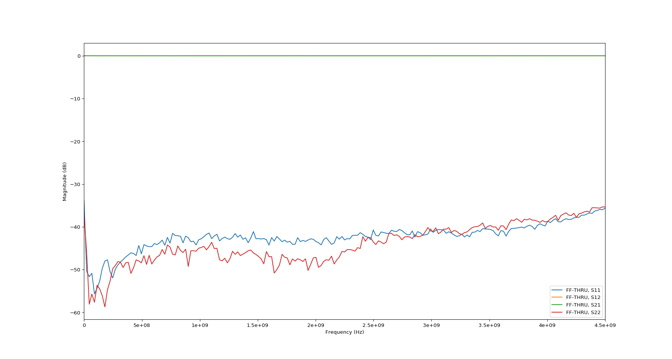

Phase:

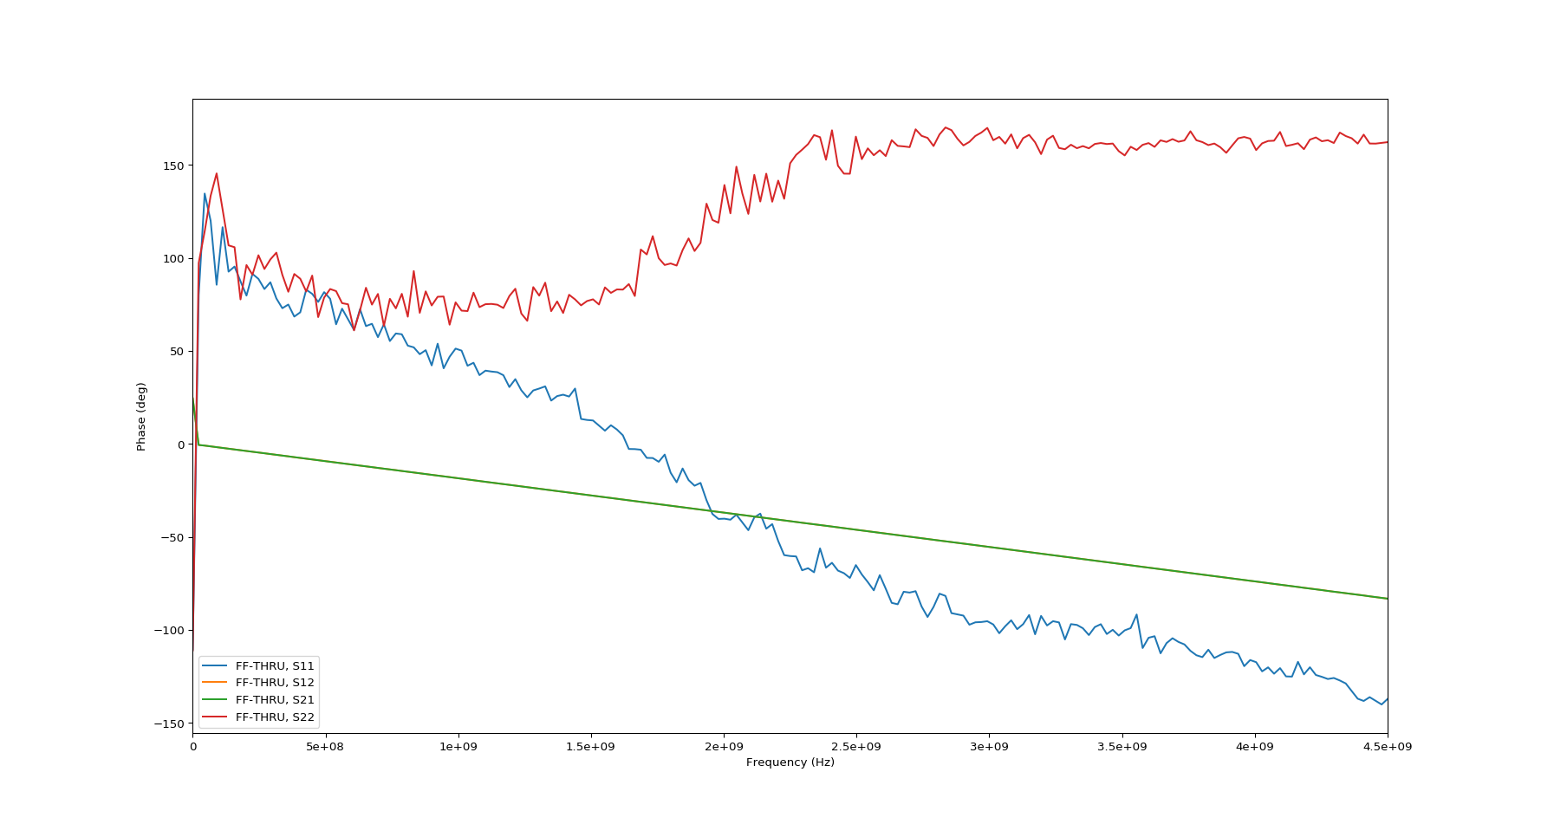

Smith Chart:

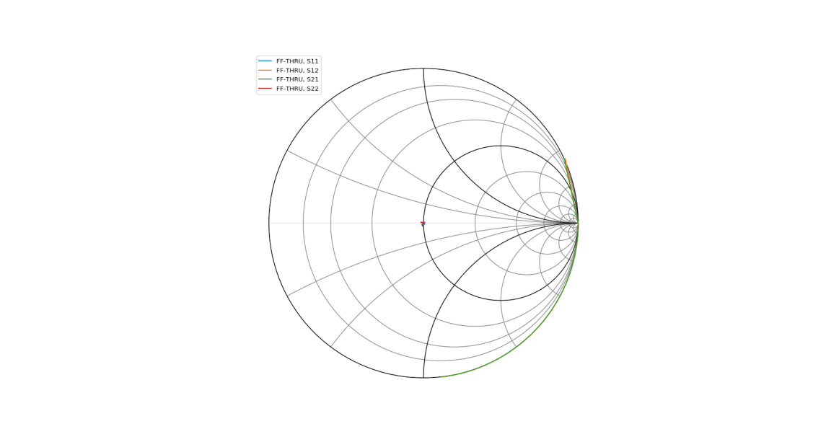

There is little loss through the adapter between the two ports, because the magnitude of S21 and S12 parameters are basically 0 dB. Besides, it is matched to 50ohms, because S11 and S22 are very small and they are in a very small region among the origin point of smith chart, which indicates the reflection is very little.

4.S-parameters of the female–female through board

Magnitude(in dB):

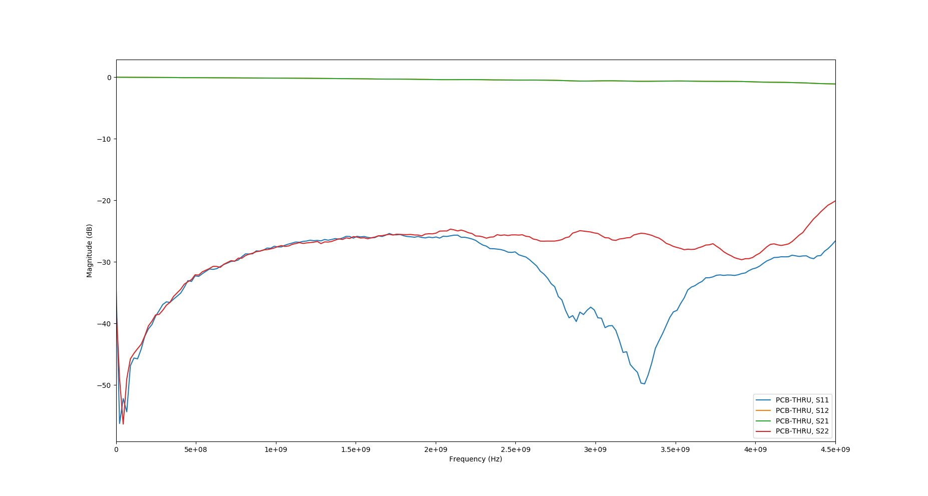

Phase:

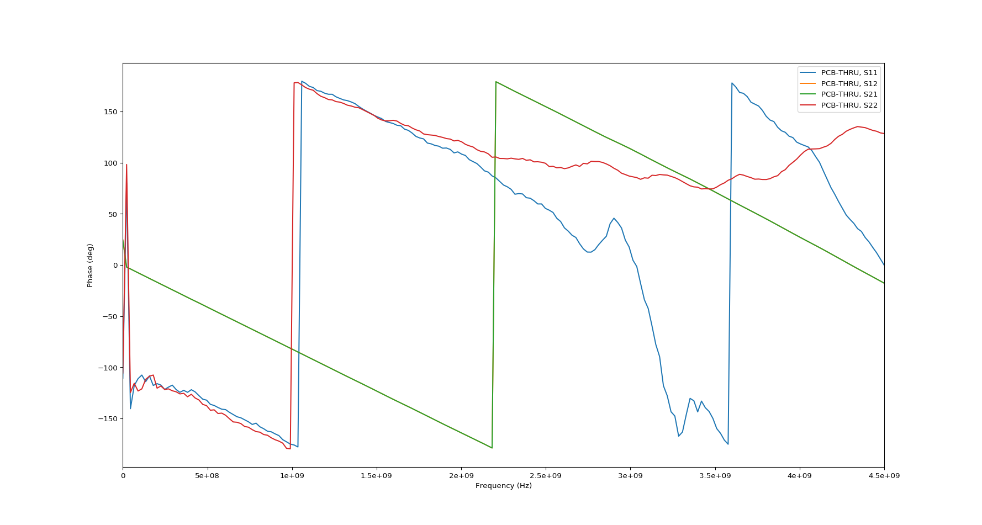

Smith Chart:

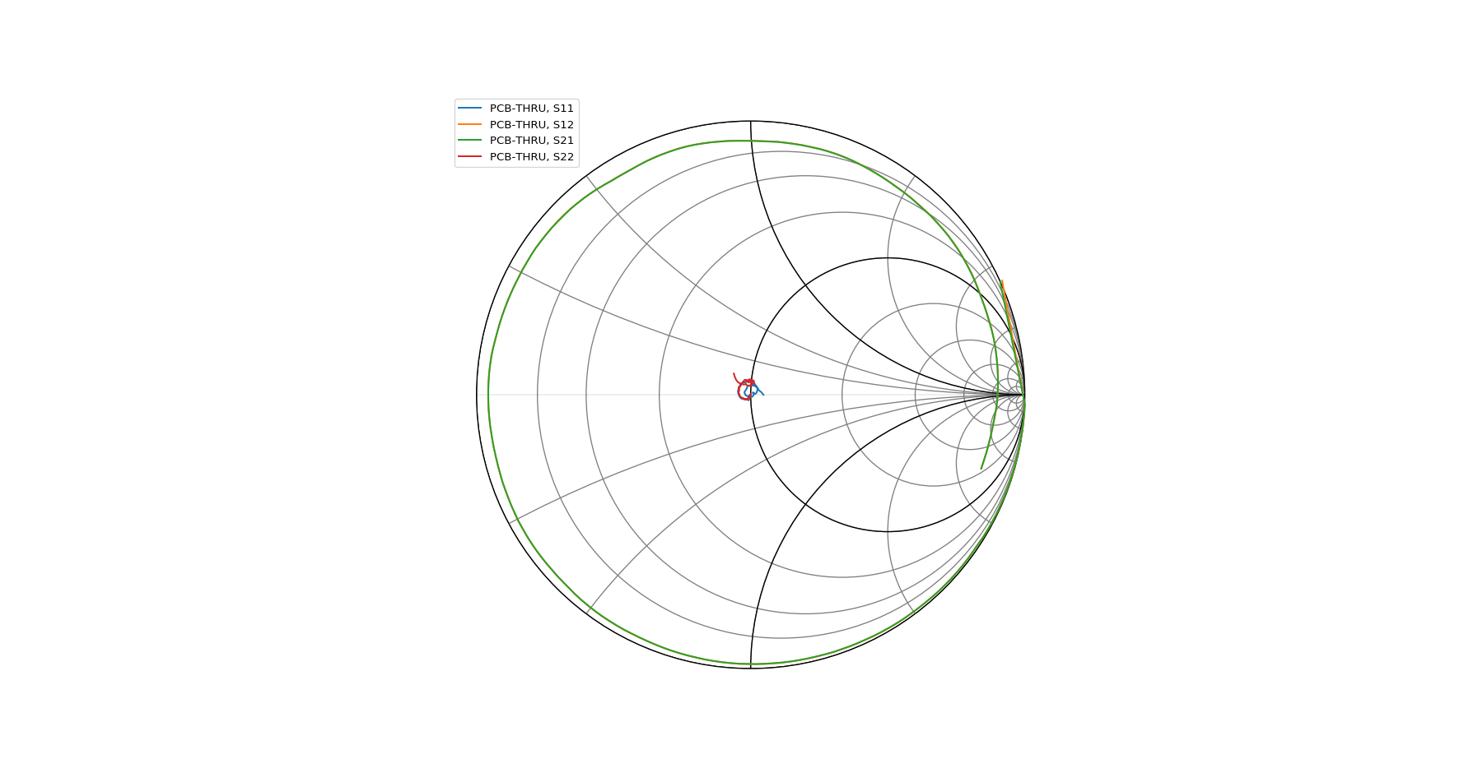

The loss of through board is much larger than that of the female-female through adapter. As the frequency increases, the magnitudes of S12 and S21 are smaller than 0dB, which indicates that there is loss when signal going through the board from one port to another.

5.

6.S11 or S22 of the “Open” board

The magnitude of S11 and S22 of “Open board”:

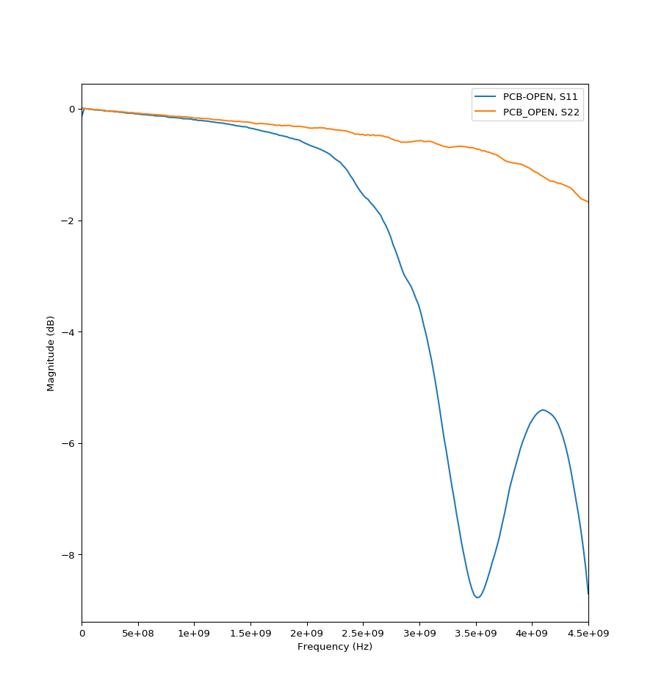

Phase of S11 and S22:

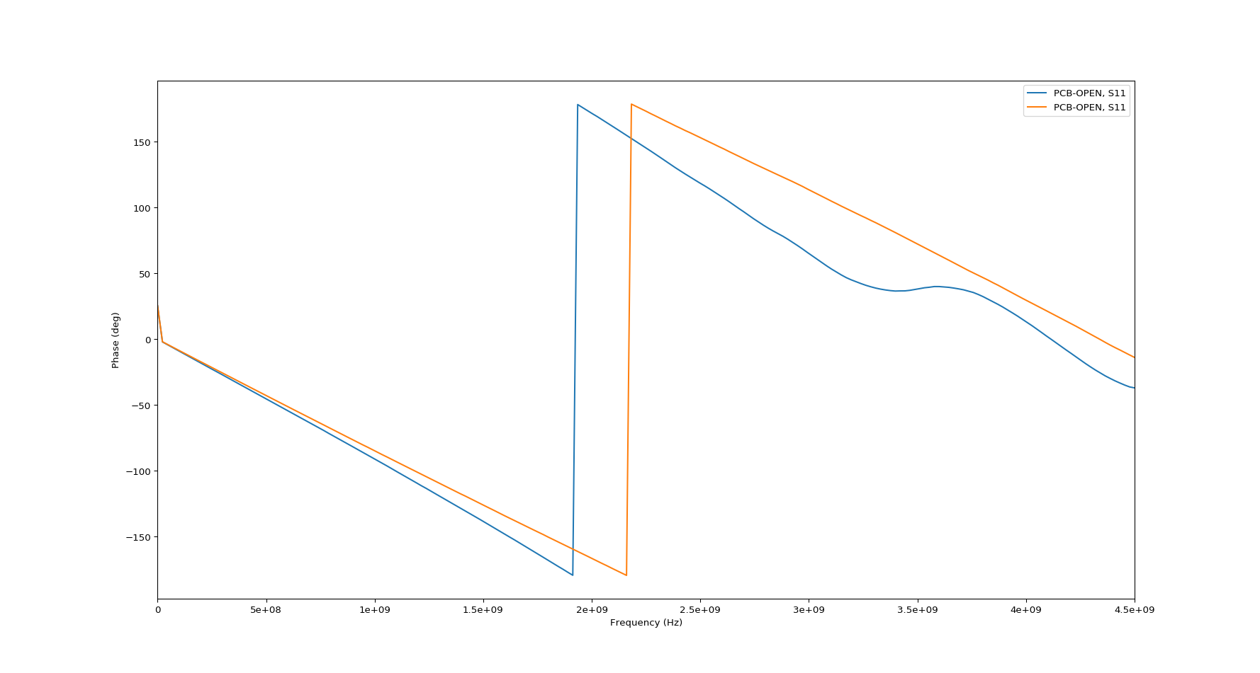

Smith Chart of S11 and S22:

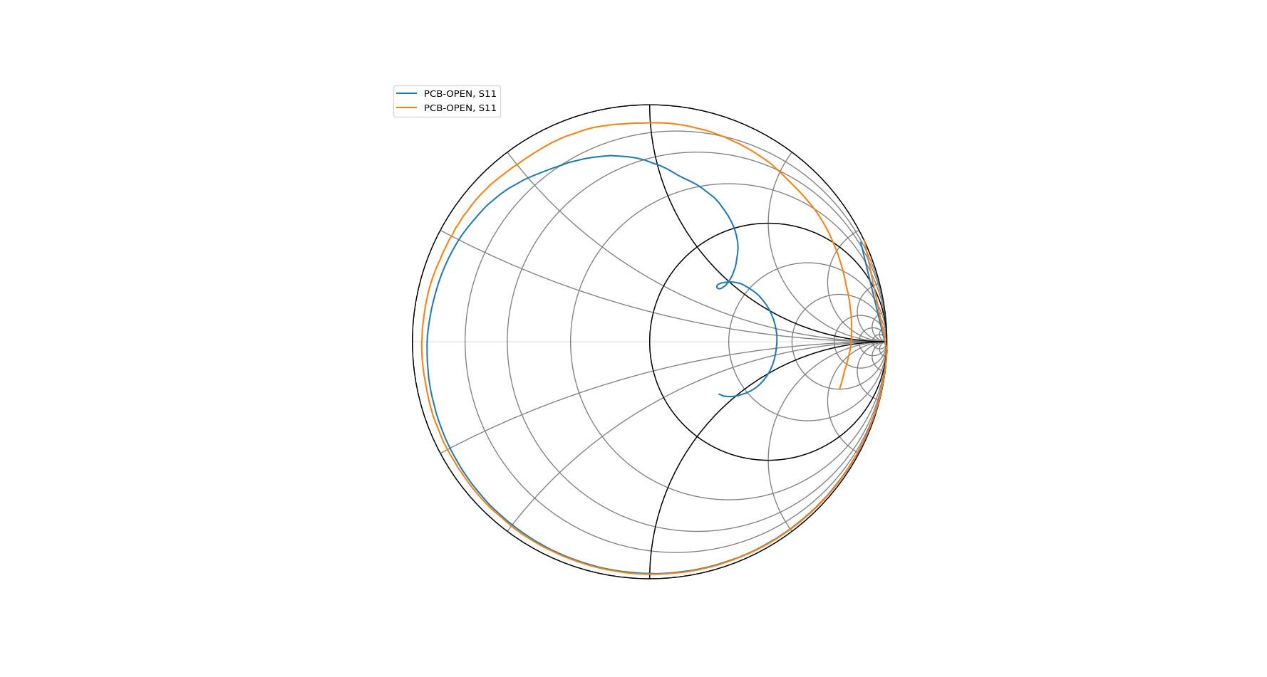

The ideal open should make magnitude of S11 and S22 to be 1 and phase to be 0. For the S parameter of “Open board”, the magnitude decrease and the phase also decrease with frequency, which is because there exist capacitor between the metals on the board and the capacitor make the Open termination in high frequency no longer ideal.